# Angular JS

Open source

<https://angularjs.org/>

https://www.tutorialspoint.com/angularjs/angularjs_environment.htm

## General Features

The general features of AngularJS are as follows −

* AngularJS is a efficient framework that can create Rich Internet Applications (RIA).
* AngularJS provides developers an options to write client side applications using JavaScript in a clean Model View Controller (MVC) way.
* Applications written in AngularJS are cross-browser compliant. AngularJS automatically handles JavaScript code suitable for each browser.
* AngularJS is open source, completely free, and used by thousands of developers around the world. It is licensed under the Apache license version 2.0.

Overall, AngularJS is a framework to build large scale, high-performance, and easyto-maintain web applications.

## Core Features

The core features of AngularJS are as follows −

* **Data-binding** − It is the automatic synchronization of data between model and view components.
* **Scope** − These are objects that refer to the model. They act as a glue between controller and view.
* **Controller** − These are JavaScript functions bound to a particular scope.
* **Services** − AngularJS comes with several built-in services such as $http to make a XMLHttpRequests. These are singleton objects which are instantiated only once in app.
* **Filters** − These select a subset of items from an array and returns a new array.
* **Directives** − Directives are markers on DOM elements such as elements, attributes, css, and more. These can be used to create custom HTML tags that serve as new, custom widgets. AngularJS has built-in directives such as ngBind, ngModel, etc.
* **Templates** − These are the rendered view with information from the controller and model. These can be a single file (such as index.html) or multiple views in one page using *partials*.
* **Routing** − It is concept of switching views.
* **Model View Whatever** − MVW is a design pattern for dividing an application into different parts called Model, View, and Controller, each with distinct responsibilities. AngularJS does not implement MVC in the traditional sense, but rather something closer to MVVM (Model-View-ViewModel). The Angular JS team refers it humorously as Model View Whatever.
* **Deep Linking** − Deep linking allows to encode the state of application in the URL so that it can be bookmarked. The application can then be restored from the URL to the same state.
* **Dependency Injection** − AngularJS has a built-in dependency injection subsystem that helps the developer to create, understand, and test the applications easily.

## Concepts

The following diagram depicts some important parts of AngularJS which we will discuss in detail in the subsequent chapters.

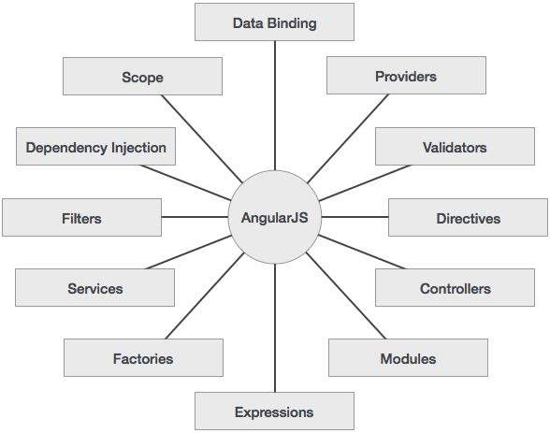

## Advantages of AngularJS

The advantages of AngularJS are −

* It provides the capability to create Single Page Application in a very clean and maintainable way.
* It provides data binding capability to HTML. Thus, it gives user a rich and responsive experience.
* AngularJS code is unit testable.
* AngularJS uses dependency injection and make use of separation of concerns.
* AngularJS provides reusable components.
* With AngularJS, the developers can achieve more functionality with short code.
* In AngularJS, views are pure html pages, and controllers written in JavaScript do the business processing.

On the top of everything, AngularJS applications can run on all major browsers and smart phones, including Android and iOS based phones/tablets.

## Disadvantages of AngularJS

Though AngularJS comes with a lot of merits, here are some points of concern −

* **Not Secure** − Being JavaScript only framework, application written in AngularJS are not safe. Server side authentication and authorization is must to keep an application secure.
* **Not degradable** − If the user of your application disables JavaScript, then nothing would be visible, except the basic page.

## AngularJS Directives

The AngularJS framework can be divided into three major parts −

* **ng-app** − This directive defines and links an AngularJS application to HTML.
* **ng-model** − This directive binds the values of AngularJS application data to HTML input controls.
* **ng-bind** − This directive binds the AngularJS application data to HTML tags.

**Install Angular JS**

1. **Download angular.min.js and add <script> to your html file**

**(working in Chrome but not in Firefox)**

## Prerequisites

Before you begin, make sure your development environment includes Node.js® and an npm package manager.

### Node.js

Angular requires Node.js version 8.x or 10.x.

* To check your version, run node -v in a terminal/console window.
* To get Node.js, go to [nodejs.org](https://nodejs.org/).

### npm package manager

Angular, the Angular CLI, and Angular apps depend on features and functionality provided by libraries that are available as [npm packages](https://docs.npmjs.com/getting-started/what-is-npm). To download and install npm packages, you must have an npm package manager.

This Quick Start uses the [npm client](https://docs.npmjs.com/cli/install) command line interface, which is installed with Node.js by default.

To check that you have the npm client installed, run npm -v in a terminal/console window.

## Step 1: Install the Angular CLI

You use the Angular CLI to create projects, generate application and library code, and perform a variety of ongoing development tasks such as testing, bundling, and deployment.

Install the Angular CLI globally.

To install the CLI using npm, open a terminal/console window and enter the following command:

content_copynpm install -g @angular/cli

## Step 2: Create a workspace and initial application

You develop apps in the context of an Angular [**workspace**](https://angular.io/guide/glossary#workspace). A workspace contains the files for one or more [**projects**](https://angular.io/guide/glossary/#project). A project is the set of files that comprise an app, a library, or end-to-end (e2e) tests.

To create a new workspace and initial app project:

1. Run the CLI command ng new and provide the name my-app, as shown here:

content_copyng new my-app

1. The ng new command prompts you for information about features to include in the initial app project. Accept the defaults by pressing the Enter or Return key.

The Angular CLI installs the necessary Angular npm packages and other dependencies. This can take a few minutes.

It also creates the following workspace and starter project files:

* A new workspace, with a root folder named my-app
* An initial skeleton app project, also called my-app (in the src subfolder)
* An end-to-end test project (in the e2e subfolder)
* Related configuration files

The initial app project contains a simple Welcome app, ready to run.

## Step 3: Serve the application

Angular includes a server, so that you can easily build and serve your app locally.

1. Go to the workspace folder (my-app).
2. Launch the server by using the CLI command ng serve, with the --open option.

content_copycd my-app

ng serve --open

The ng serve command launches the server, watches your files, and rebuilds the app as you make changes to those files.

The --open (or just -o) option automatically opens your browser to [http](https://angular.io/api/common/http)://localhost:4200/.

Your app greets you with a message:

## Step 4: Edit your first Angular component

[Components](https://angular.io/guide/glossary#component) are the fundamental building blocks of Angular applications. They display data on the screen, listen for user input, and take action based on that input.

As part of the initial app, the CLI created the first Angular component for you. It is the root component, and it is named app-root.

1. Open ./src/app/app.component.ts.
2. Change the title property from 'my-app' to 'My First Angular App'.

src/app/app.component.ts

content_copy@[Component](https://angular.io/api/core/Component)({

selector: 'app-root',

templateUrl: './app.component.html',

[styleUrls](https://angular.io/api/core/Component#styleUrls): ['./app.component.css']

})

export class AppComponent {

title = 'My First Angular App!';

}

The browser reloads automatically with the revised title. That's nice, but it could look better.

1. Open ./src/app/app.component.css and give the component some style.

src/app/app.component.css

content_copyh1 {

color: #369;

font-family: Arial, Helvetica, sans-serif;

font-size: 250%;

}

### Add Some Control

#### Data Binding

Data-binding is an automatic way of updating the view whenever the model changes, as well as updating the model whenever the view changes. This is awesome because it eliminates DOM manipulation from the list of things you have to worry about.

#### Controller

Controllers are the behavior behind the DOM elements. AngularJS lets you express the behavior in a clean readable form without the usual boilerplate of updating the DOM, registering callbacks or watching model changes.

# D3 JS

Data Driven Documentation java script

### Scalable Vector Graphics (SVG)

We can draw other shapes in SVG such as − Line, Circle, Ellipse, Text and Path.

d3.**select**("div.myclass").**append**("span").**text**("from D3.js");

<**svg** width = "500" height = "500">

<**rect** x = "0" y = "0" width = "300" height = "200"></**rect**>

</**svg**>

<!DOCTYPE html>

<html>

<head>

<script type = "text/javascript" src = "https://d3js.org/d3.v4.min.js"></script>

</head>

<body>

<div class = "myclass">

Hello World!

</div>

<script>

d3.select("div.myclass").append("span").text("from D3.js");

</script>

</body>

</html>

### The html() Method

The html() method is used to set the html content of the selected / appended elements.

|  |
| --- |
| <!DOCTYPE html>  <html>  <head>  <script type = "text/javascript" src = "https://d3js.org/d3.v4.min.js"></script>  </head>  <body>  <div class = "myclass">  Hello World! sdfasdfadsfs  </div>    <script>  d3.select**(".myclass").**html("Hello World! <span>from D3.js</span>");  </script>  </body>  </html>  **output :** Hello World! from D3.js |

|  |  |
| --- | --- |
| <!DOCTYPE html>  <html>  <head>  <script type = "text/javascript" src = "https://d3js.org/d3.v4.min.js"></script>  </head>  <body>  <div class = "myclass">  Hello World! Good Morning  </div>    <script>  d3.select**("#myclass").**html("Hello World! <span>from D3.js</span>");  </script>  </body>  </html>  **output :** Hello World! Good Morning |  |

### The attr() Method

The attr() method is used to add or update the attribute of the selected elements. Create a webpage “select_and_modify.html” and add the following code.

|  |
| --- |
| <!DOCTYPE html>  <html>  <head>  <script type = "text/javascript" src = "https://d3js.org/d3.v4.min.js"></script>  </head>  <body>  <div class = "myclass">  Hello World!  </div>    <script>  d3.select(".myclass").attr("style", "color: red");  </script>  </body>  </html>  Output : Hello World! |

### The style() Method

The style() method is used to set the style property of the selected elements. Create a webpage “select_and_style.html” and add the following code.

|  |
| --- |
| <!DOCTYPE html>  <html>  <head>  <script type = "text/javascript" src = "https://d3js.org/d3.v4.min.js"></script>  </head>  <body>  <div class = "myclass">  Hello World!  </div>    <script>  d3.select(".myclass").style("color", "red");  </script>  </body>  </html>  Output : Hello World! |

### The classed() Method

The classed() method is exclusively used to set the “class” attribute of an HTML element. Since, a single HTML element can have multiple classes; we need to be careful while assigning a class to an HTML element. This method knows how to handle one or many classes on an element, and it will be performant.

* **Add class** − To add a class, the second parameter of the classed method must be set to true. It is defined below −

d3.select(".myclass").classed("myanotherclass", true);

* **Remove class** − To remove a class, the second parameter of the classed method must be set to false. It is defined below −

d3.select(".myclass").classed("myanotherclass", false);

* **Check class** − To check for the existence of a class, just leave off the second parameter and pass the class name you are querying. This will return true, if it exists, false, if it does not.

d3.select(".myclass").classed("myanotherclass");

## The selectAll() Method

The selectAll() method is used to select multiple elements in the HTML document. The select method selects the first element, but the selectAll method selects all the elements that match the specific selector string. In case the selection matches none, then it returns an empty selection. We can chain all the appending modifying methods, **append(), html(), text(), attr(), style(), classed(),** etc., in the selectAll() method as well. In this case, the methods will affect all the matching elements. Let us understand by creating a new webpage “select_multiple.html” and add the following script –

|  |
| --- |
| <!DOCTYPE html>  <html>  <head>  <script type = "text/javascript" src = "https://d3js.org/d3.v4.min.js"> </script>  </head>  <body>  <h2 class = "myclass">Message</h2>  <div class = "myclass">  Hello World!  </div>    <script>  d3.selectAll(".myclass").attr("style", "color: red");  </script>  </body>  </html> |

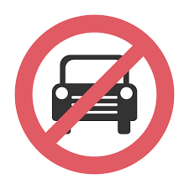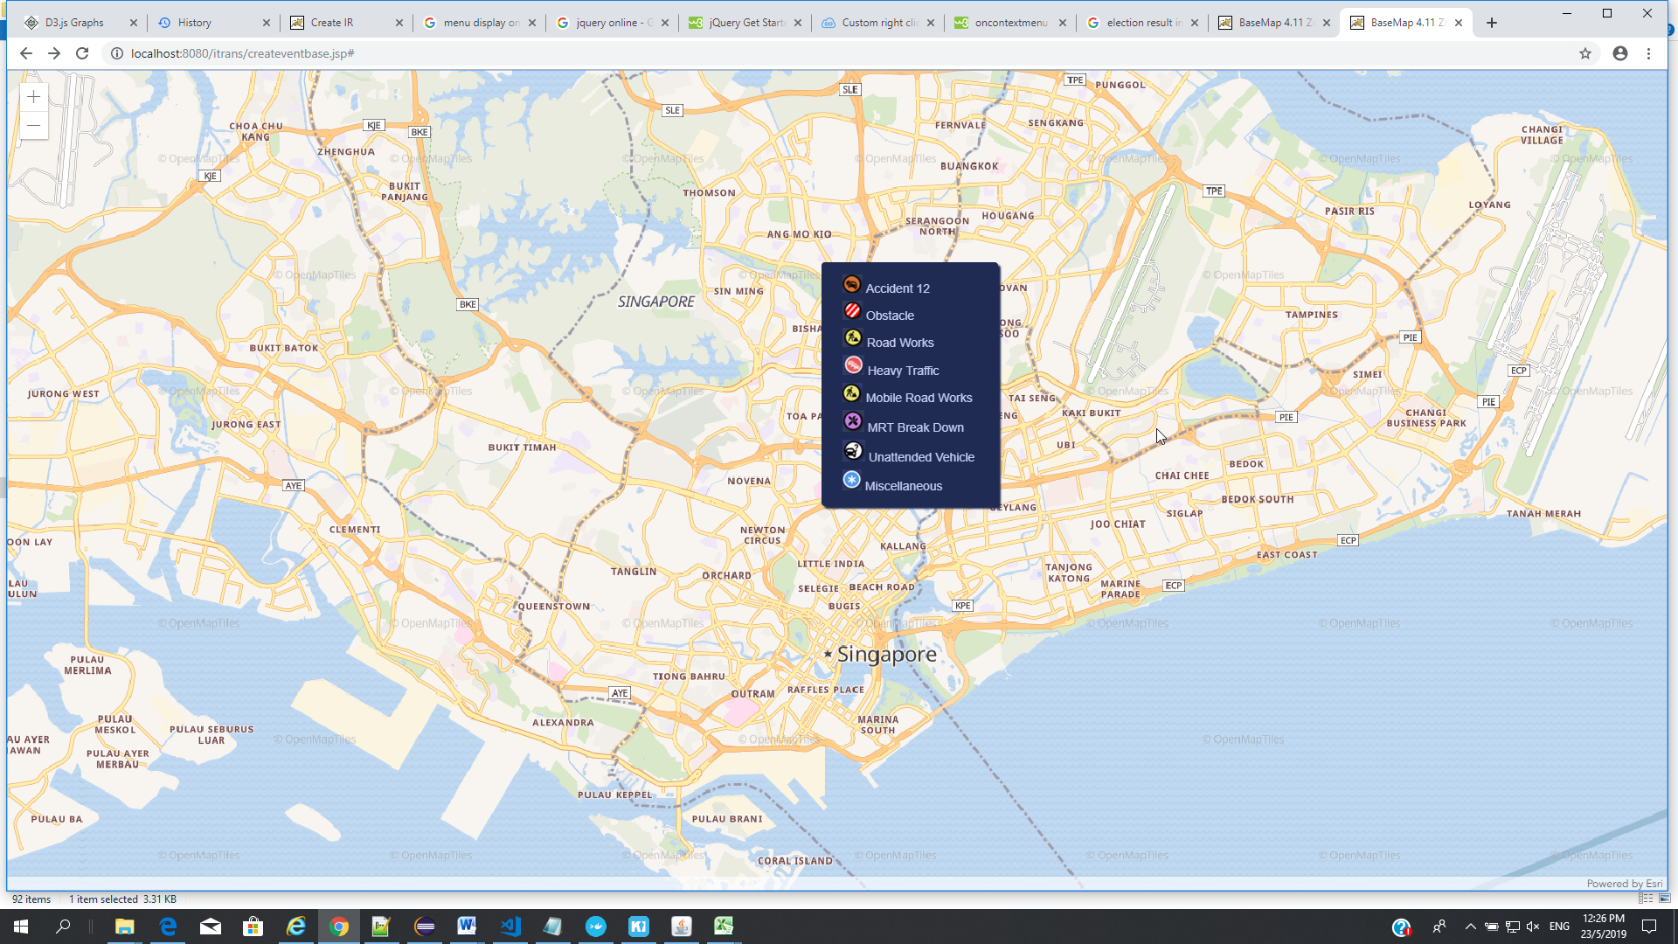

# Angular 7

**SPA – Single Page Application**

# Angular 6

## Install NoteJS

Download from NODEJS SITE.

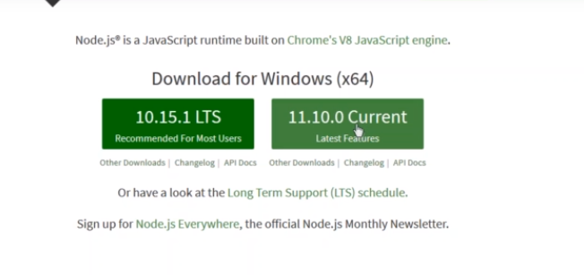

## Install CLI

**Command prompt**

C:\npm install @angular/cli -g

C:\cd angular

Cd:\angular> ng new projectname --style=scss --routing --skip-install

Cd:\angular\cd projectname

Cd:\angular\projectname>npm install

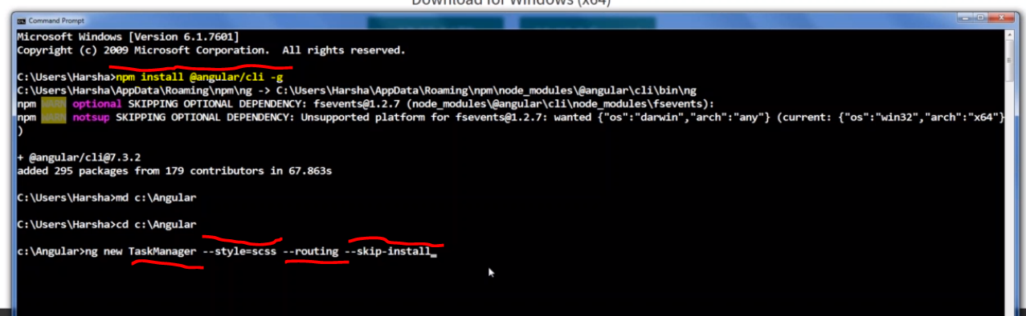

**TaskManager** is Angular Application Name

**--style=scss** is stylesheet file

**--routing** is stylesheet file

**--skip-install** is skip the npm installation

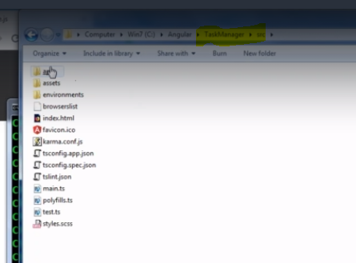

Install the npm to your project folder

**Cd “Foldername”** get into the folder

**npm install “Foldername”** install the angular package



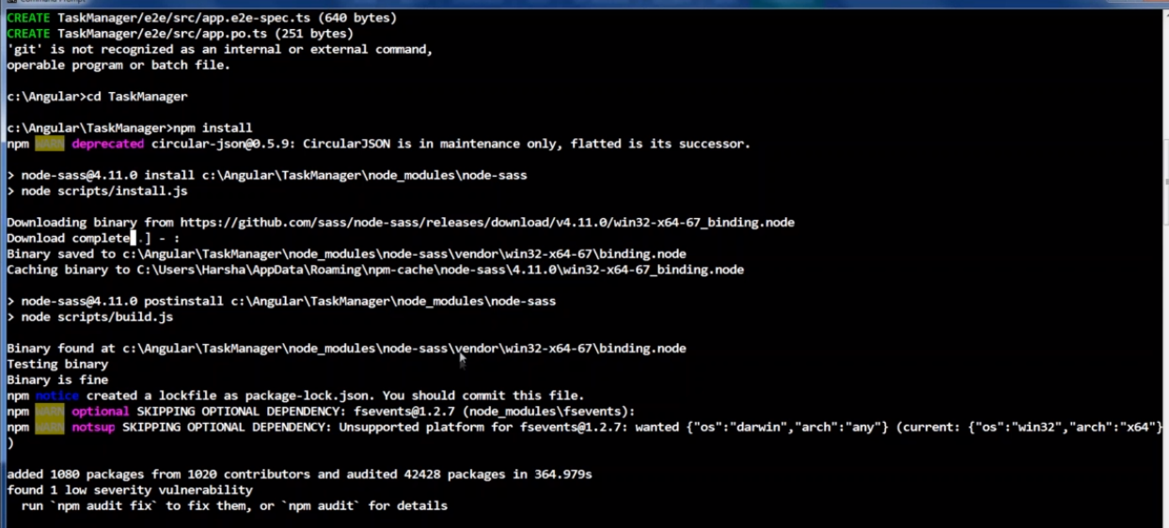

“Project folder” extraction from visual studio

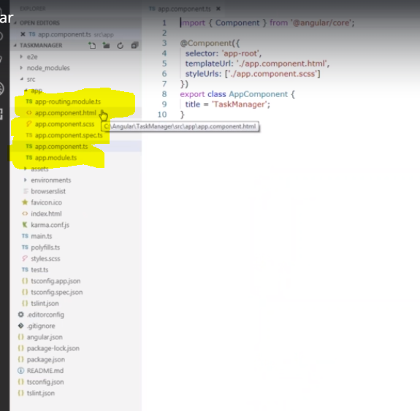

## To run the application

**Command prompt**

Cd:\angular\projectname>ng serve --open --port=4200

**ng serve** compile and run the application

**--open** open a browser

**--port=5200** open port 5200

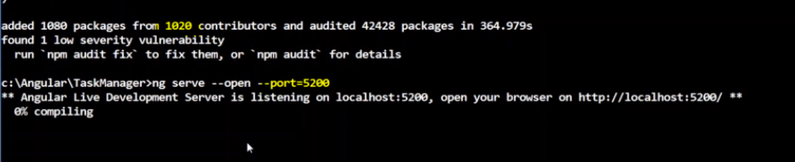

Default port 1020

When you run you can give own port number

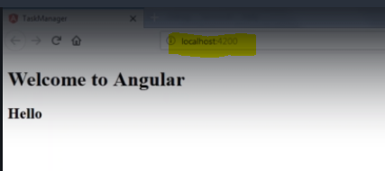

## Install bootstrap

Go to the project folder

**Command prompt**

Cd:\angular\projectname> npm install jquery --save

Cd:\angular\projectname> npm install popper.js --save

Cd:\angular\projectname> npm install bootstrap --save

Install fonts

Cd:\angular\projectname> npm install font-awesome --save

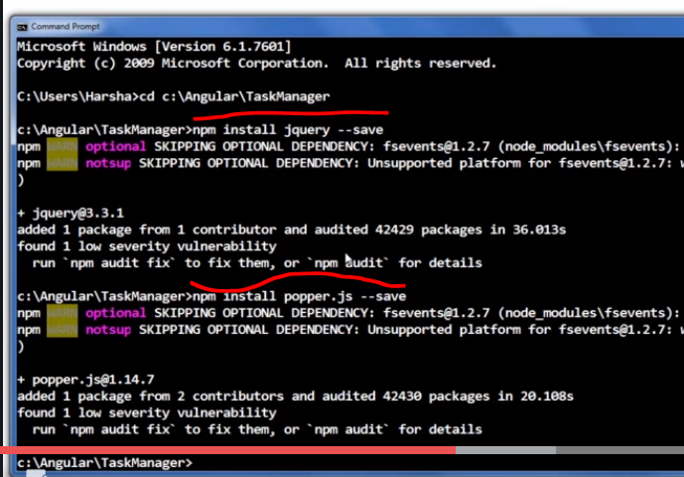

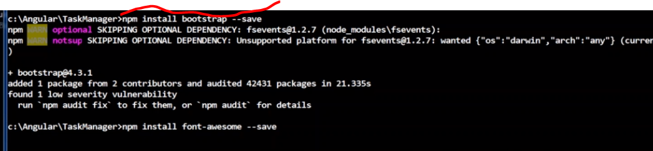

## Add js to angular.json file

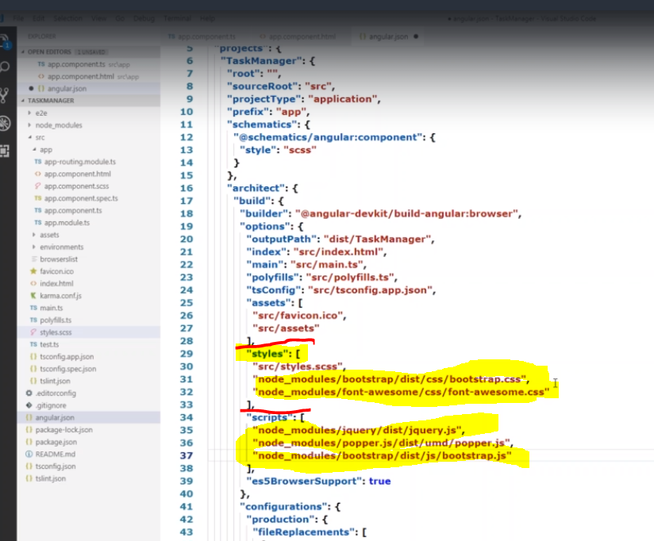

## Restart Angular server

**To take above .js changes file added**

**start the sever**

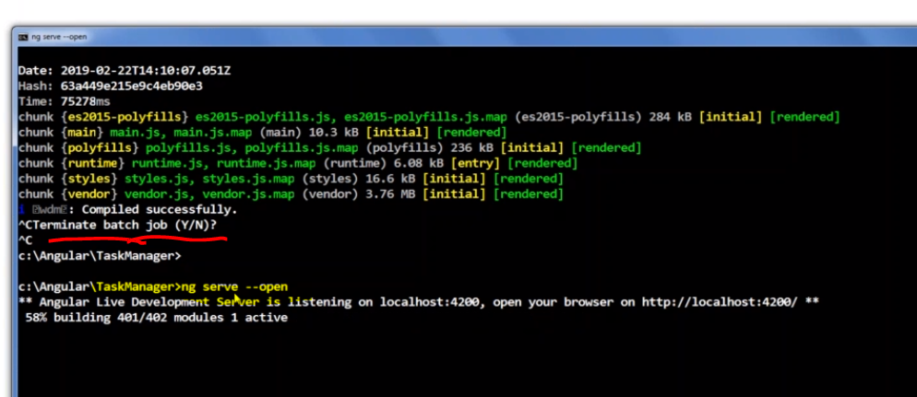

## Rest API Call

In app.module.ts





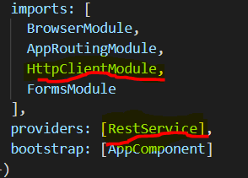

* 1. **Router**



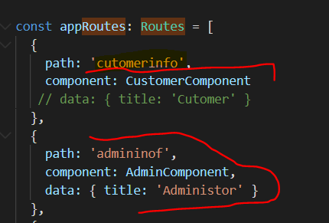

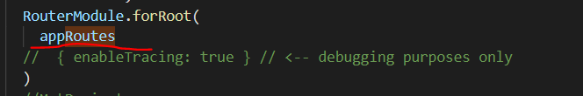

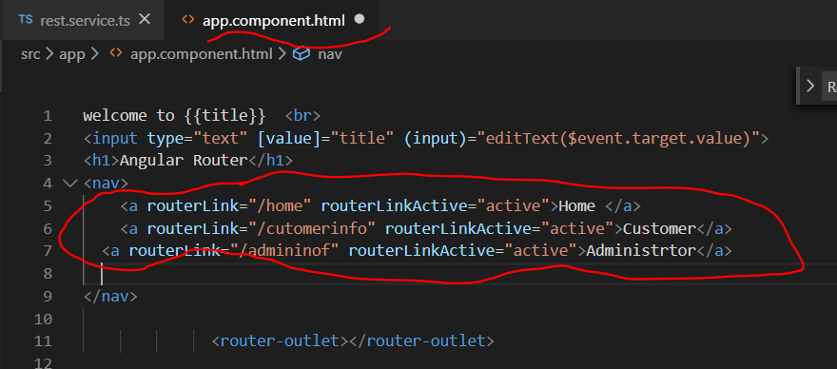

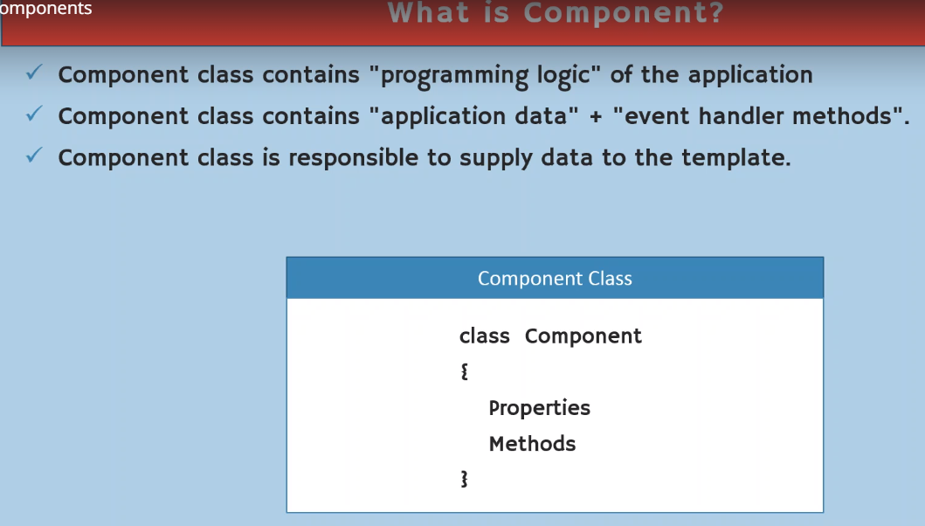

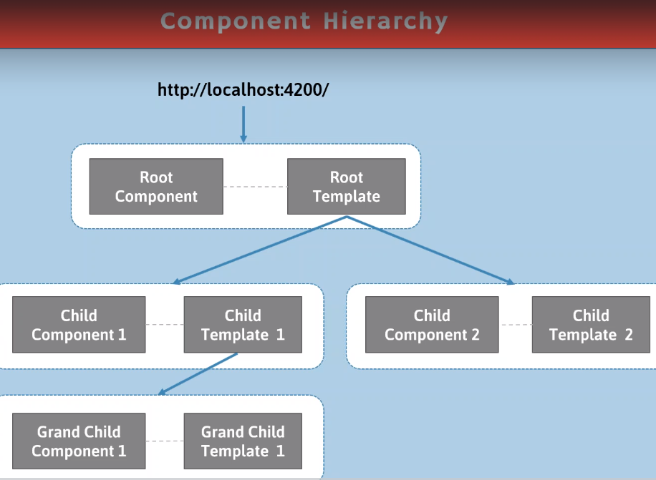

## Component

Write your new functionality

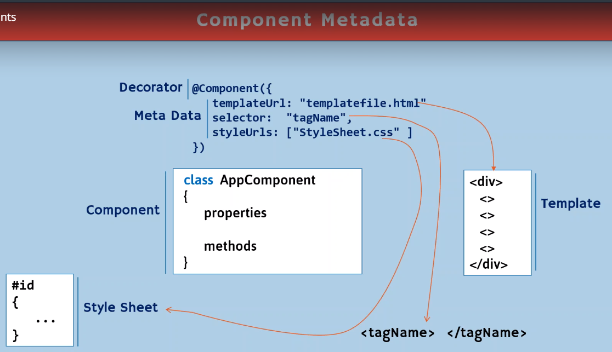

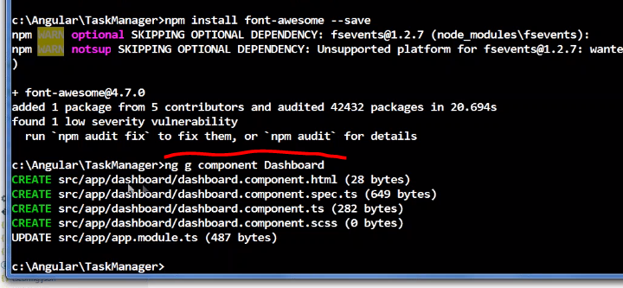

ng g component Dashboard

ng g component About

“Dashboard” and “About” are different functionality

## Router

Take to different url like “href”

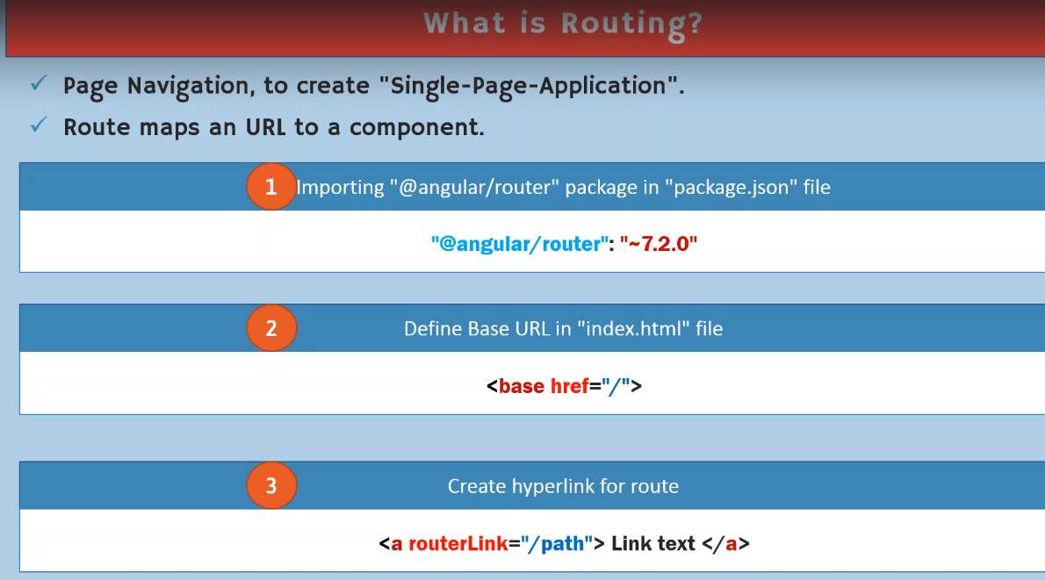

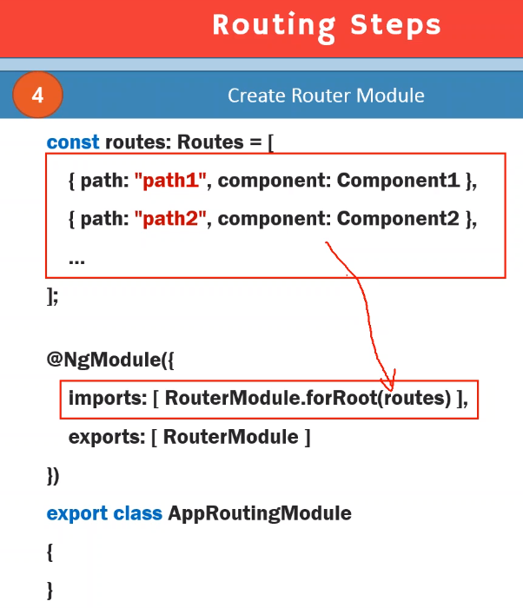

Basic routing in angular

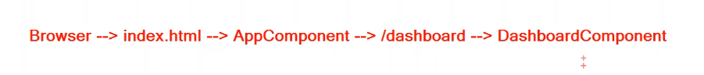

## Project Folder Structure

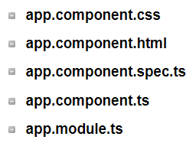

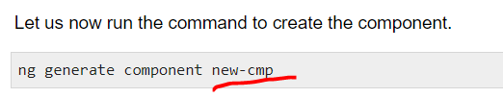

**Ng generate component new-cmp**

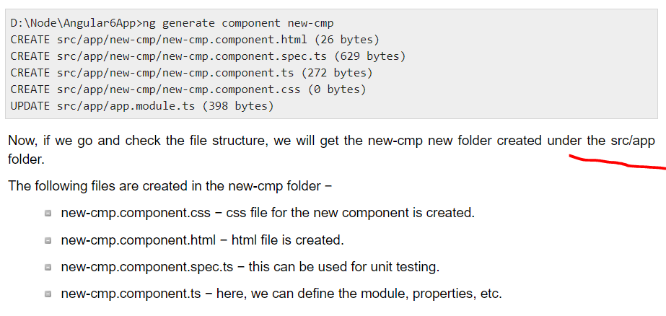

Changes are added to the app.module.ts file as follows

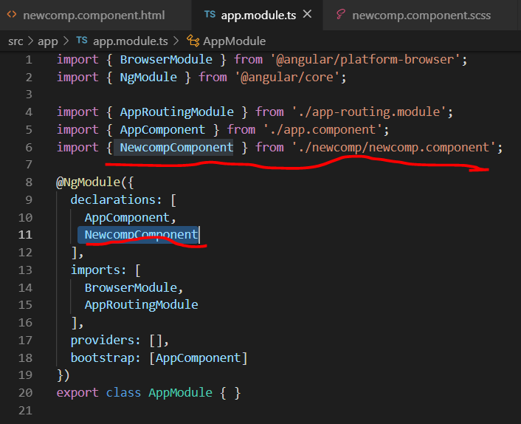

## New Project

* 1. Open a folder
  2. Create angular project

**Command prompt**

C:\npm install @angular/cli -g

C:\cd angular

Cd:\angular> ng new projectname --style=scss --routing --skip-install

Cd:\angular\cd projectname

Cd:\angular\projectname>npm install

* 1. **”Ng generate component componentname”**

**Create Component**

C:\npm install @angular/cli -g

C:\cd angular

Cd:\angular> ng new projectname --style=scss --routing --skip-install

Cd:\angular\cd projectname

Cd:\angular\projectname>npm install

|  |  |
| --- | --- |
| **Folder Name** | **Description** |
| e2e | end to end –help to test you application |
| src | source folder |
| node_Modules |  |
| angular.json | all the configuration file available here |
| package.json |  |
| app | Default Folder,  Contains : component, scss, ts, module |
| assets | add images folder |
| environments.js | local, development, production |
| browser list | Support Browser List |
| karma.confs.js | Test file |
| **components** | Header component, form component, title component, footer component, content component – To view of the user |
| **app.module.ts** | To load all the module component  1- import part  2- @NgModule - decorative  Declarations, imports, providers(Different API), bootstrap  3- Export Class AppModule{} |
| **app.component.js** | 1-import  2.@Component  3. Export Class AppComponent{} |
| **New component Creation** | 1. Import the component inside the app.module.ts  2. This file only used to import component. |
| **Comment** | New Component Creation   * Ng generate component home * .ts, .scss, .html file created * new component Automatically updated in main app.module.js |
|  | New Module Creation   * Ng generate module admin * Only module.ts file created   Component Creation inside the new module   * ng generate component admin/newcomponent name * Here ‘admin’ is project folder name * It is add ‘import’ and ‘ng module’ tag in newly created module file and not in the app.module.ts file |
| **Sample Code** | <h2 [ngStyle]="{color:'green', fontSize:'50px'}"> Working Angular js </h2>  <h2 [ngStyle]="{color:'blue', fontSize:'25px'}"> Javascript List </h2>  <ul  [ngStyle]="{color:'green', fontSize:'20px'}">    <li *ngFor="let b of myData" > {{b}}  </li>    </ul>    <h2 [ngStyle]="{color:'blue', fontSize:'25px'}"> TypeScript List </h2>    <ul>        <li *ngFor="let b of myDatats" > {{b}}      </li>        </ul>        <ul [ngStyle]="{color:'green', fontSize:'20px'}">            <li>Name      Likes</li>            </ul>            <ul *ngFor="let c of myDataObject">                <li>{{c.name}}    {{c.likes}}</li>                </ul>                <p *ngIf="num>=10">given Number {{num}} greater then 10 </p>                <p *ngIf="num<10">given Number {{num}} Not greater then 10 </p><br>  <input type="text" #txtValue>                <button (click) = "onClick(txtValue.value)">Submit</button>  *ngFor  <li *ngFor="let b of myDatats" > {{b}}      </li>  *ngIf  <p *ngIf="num>=10">given Number {{num}} greater then 10 </p>  [ngStyle]    <h2 [ngStyle]="{color:'blue', fontSize:'25px'}"> TypeScript List </h2> |

# Part 11 Angular 8 Tutorial Series by TechTechTuts in 2019: Angular 8 Modules | @NgModule Directive

<https://www.youtube.com/watch?v=YI_MhNdT-uk&list=PLjbyXovb0OczvPFgz_xvknp30MoGHApv1&index=11>

two way data binding

1. twoway data binding - (html to typescript) or (typescript to html)

- works input element (textarea, checkbox, textbox)

2. evening binding

3. data binding

**Install**

1. **NodeJS**
   1. **Using NPM to download all the angular package**
2. **CLI**
   1. **To Create Angular Application or update the existing application and setup angular package at local**
3. **SCSS** 
   1. **Super set of CSS**
   2. **Add variables, if-condition, operators etc.,**
   3. **To make your app more responsible.**
4. **ROUTING**
   1. **AngularJS routes enable you to create different URLs for different content in your application.**
   2. **AngularJS routes allow one to show multiple contents depending on which route is chosen.**
   3. **A route is specified in the URL after the # sign**
5. **Create New Angular Application Using the following command**

**Cmd>Ng new “ProjectName” --style=scss**

**--routing --skip-install**

# TypeScript

<https://www.youtube.com/watch?v=WBPrJSw7yQA>

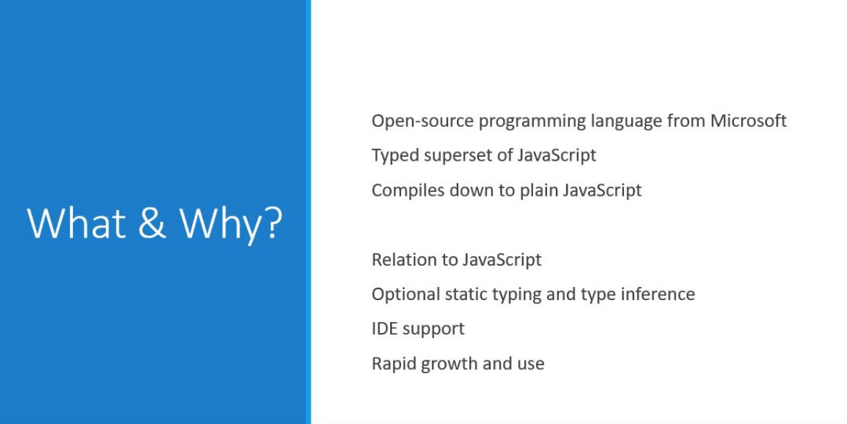

# Install

1. Download and install NoteJS and

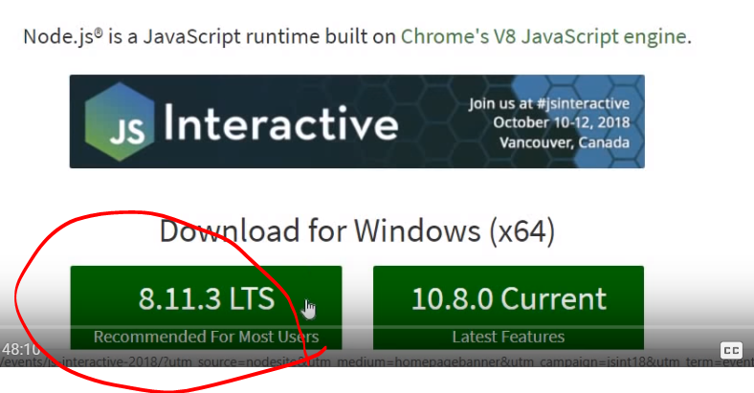

1. check with cmd

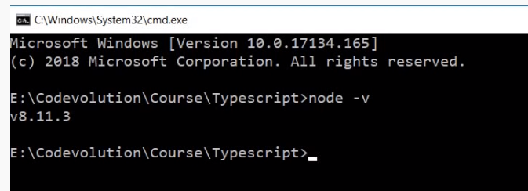

Goto personal folder and type “npm install –g typescript”

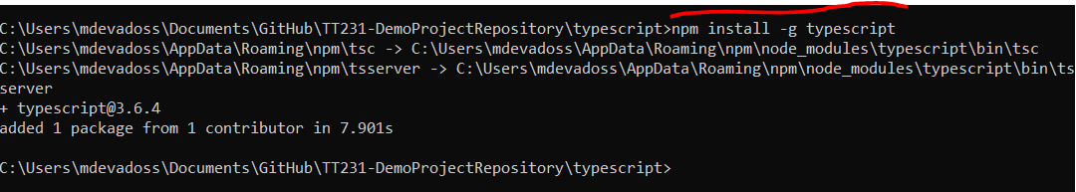

Any Error – running scrips is disabled on this system.

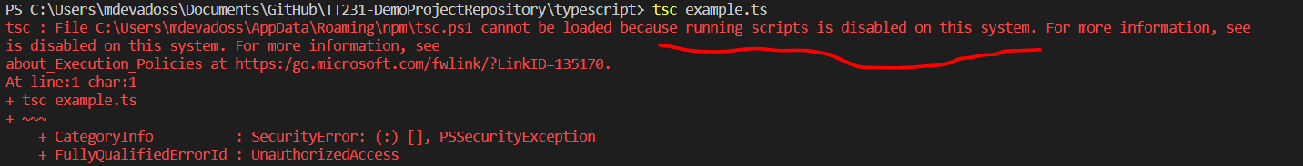

Open Windows PowerShell in Administrator mode “Set-ExecutionPolicy RemoteSigned”

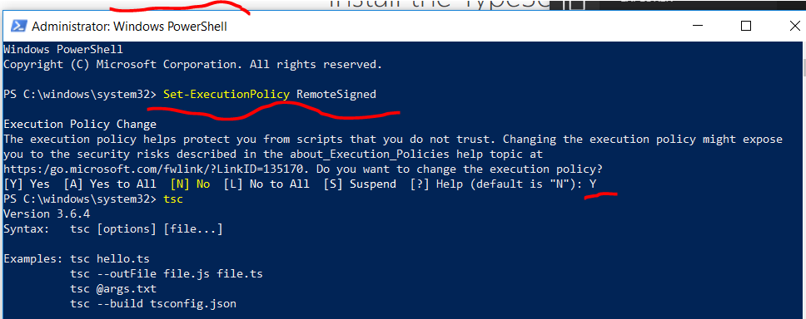

1. download IDE – Visual Studio

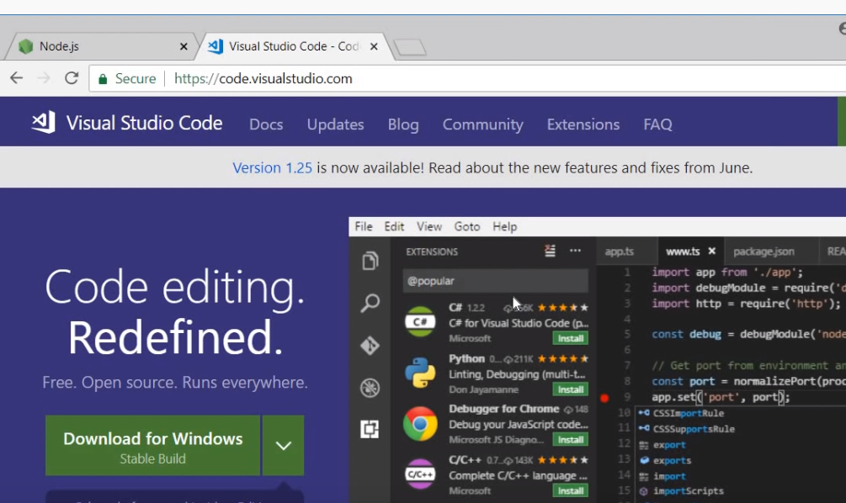

1. Write typescript file and extension is .ts

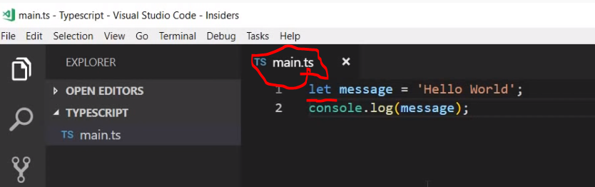

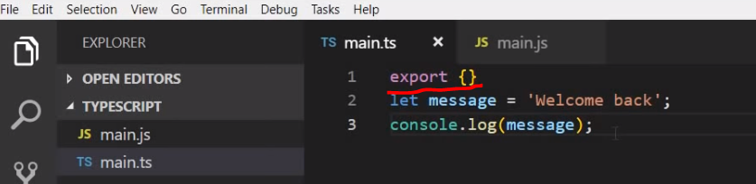

1. Using typescript container to convert into javascript

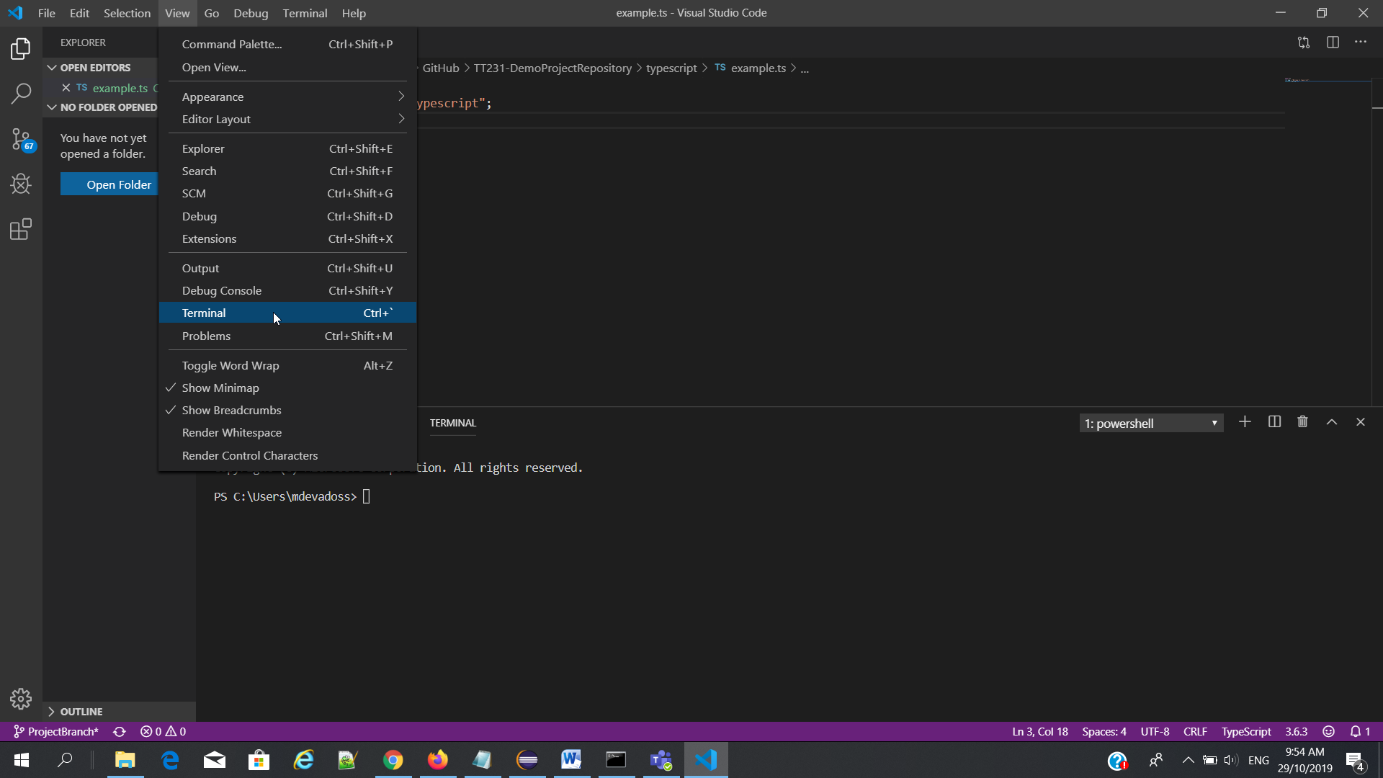 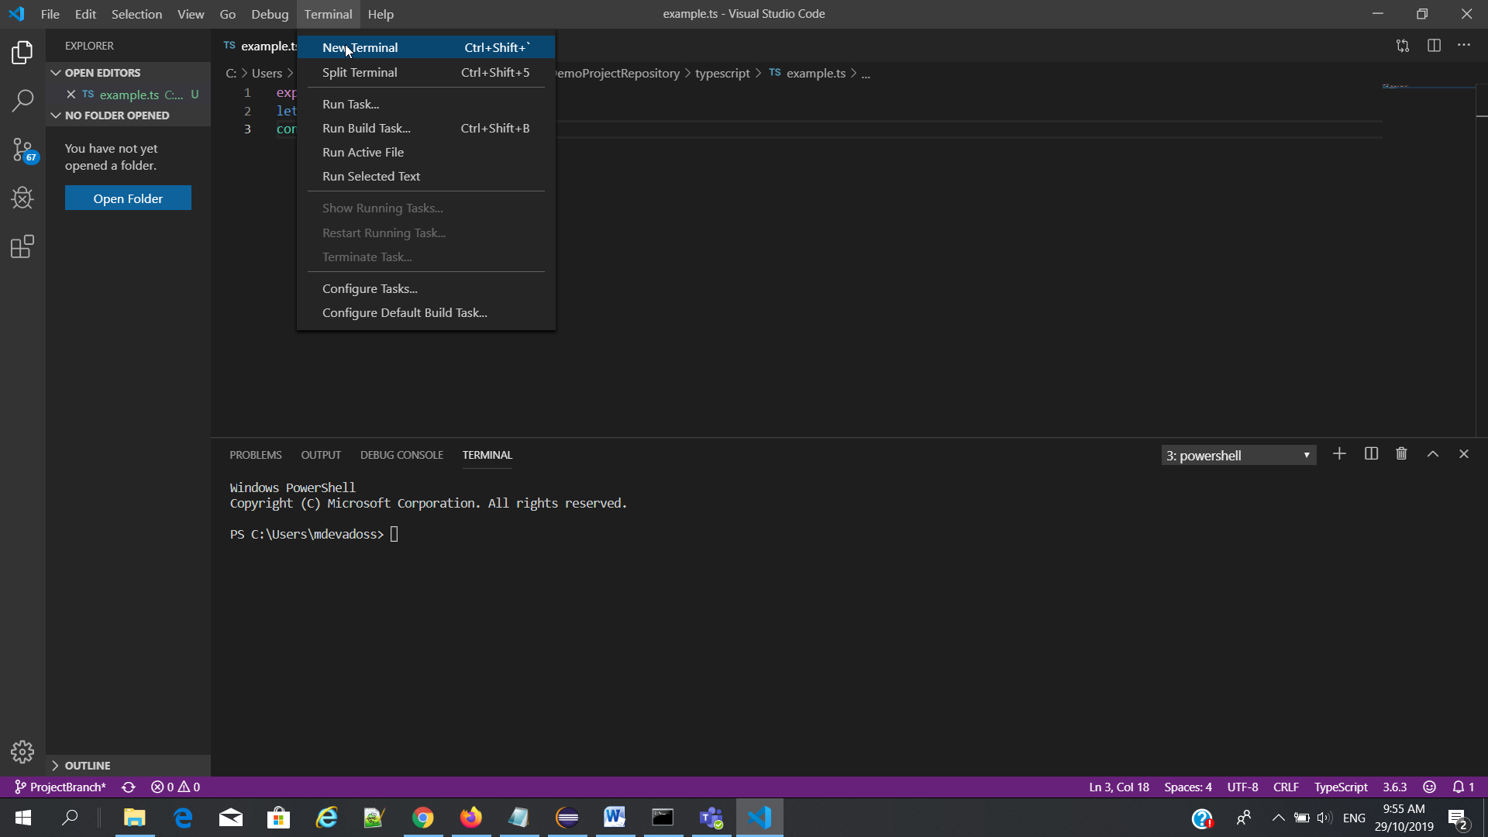

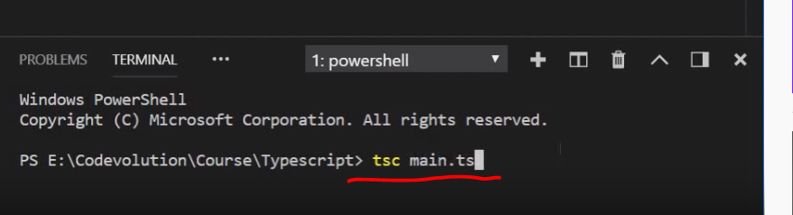

1. Java script file created main.js and “let” changed to “var”

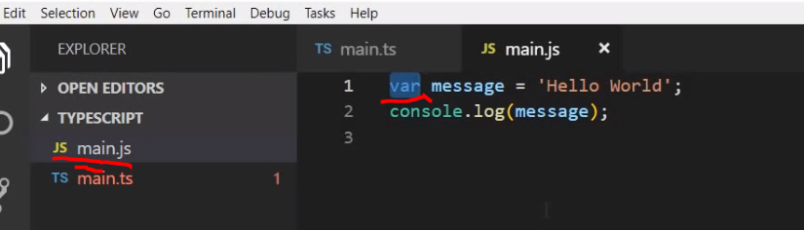

1. To Run NO NEED browser TO use “node” command using .js file

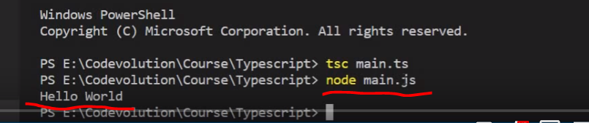

1. Using ‘watch’ command to continues compile the typescript file if you do changes. NO NEED todo “tsc mian.ts”

The compiler watching the file for changes

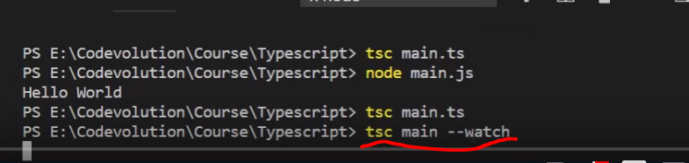

1. Variable declarations – let,const,string,number,Boolean, templatestring

* In javascript only functional scope and global scope, there is no log level scope
* Not show the duplicate variable declaration
* Typescript show error msg for the duplicate variable declaration
* “let” and “const” used for variable declaration

x show an error 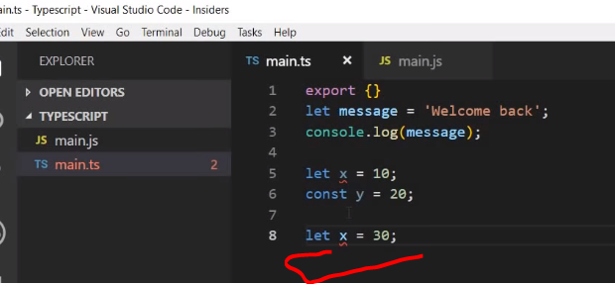

* “let” declare without initial value whereas “const” with initial value (must declare)
* let x; const b =10;

boolean, string, number variables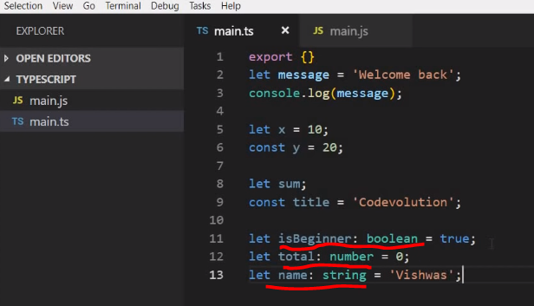

1. TemplateString – multiple line and embed value,

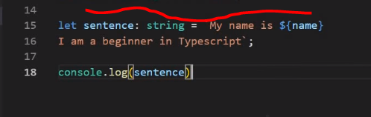 The output is My name is Vishwas

I am a beginner in typescript

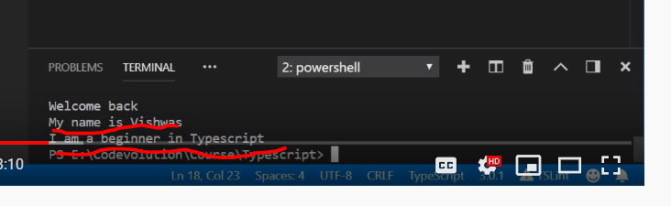

* Variable type is used to assign a **correct value to the particular variable.**
* String shows corresponding **string functions**. In case of number shows the corresponding **number function**.

1. Variable type “null” and “undefined” –

* Not in much use
* **Sub type of all other type**

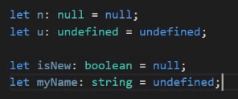

1. Array variable declaration – two ways

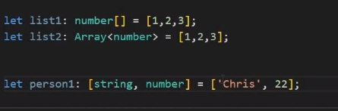

1. Enum Type – to create constant array value – take value is Color.Green is 6, Red is 5 so added 1 to 6.

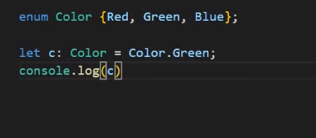

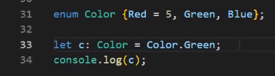

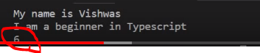

1. “Any“ type

Don’t know the other party values so use variable type “any”

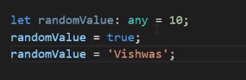

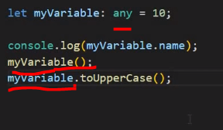

1. “Unknown” type

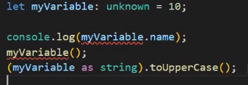

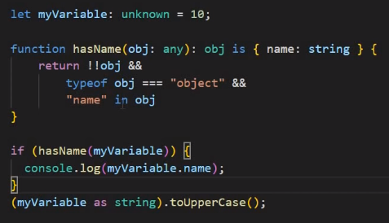

1. “multitype” – datatype
   * Assign multiple value for a same variable

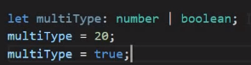

* Compare to “any” the “multitype” only have two restrict type
* function type (telesecnt support)

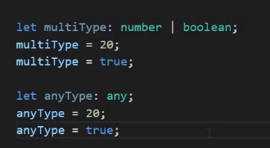

1. Functions

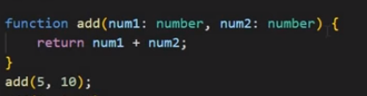

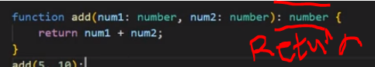 return type

1. Optional parameter with ‘?’ mark intimation

* No need to pass two values because num2 is optional
* Optional parameter always next to the required parameter

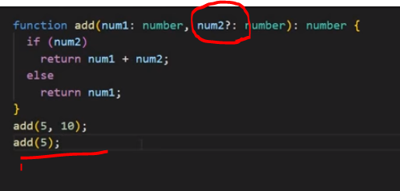

* Default parameter also ‘?’ optional parameter which has value passed in

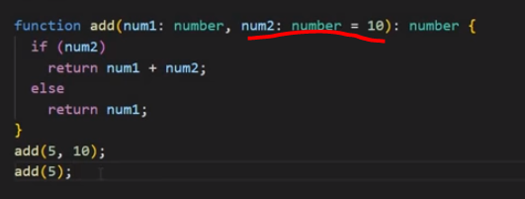

1. Interface

Function takes the person object

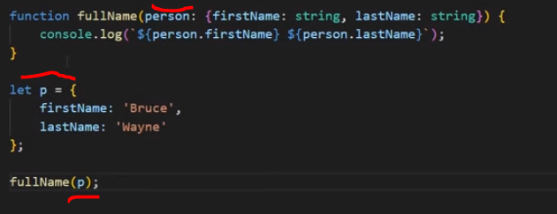

Create interface for person object

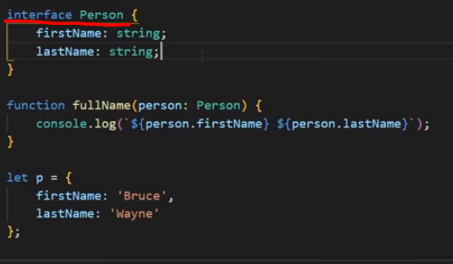

Make it ‘lastname’ – optional using (?)

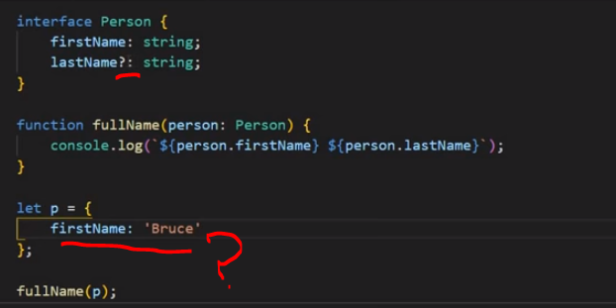

1. Class

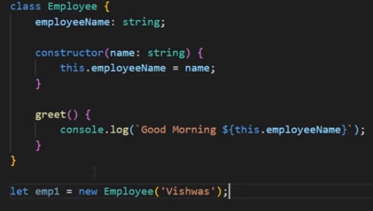

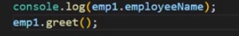

Output 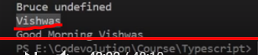

* **Class extends another class**

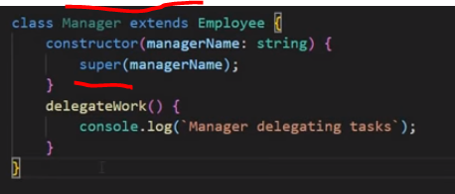

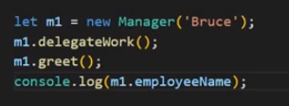

Output : 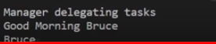

1. Access Modifiers – key words accessibility for the class.
   * Public, Private, Protected

Typescript tutorial for angular and react developers

<https://www.youtube.com/watch?v=NjN00cM18Z4>

export{}

let msg = "Welcome to typescript";

console.log("variable declaration -- " + msg);

//output (Welcome to typescript)

let namestr : String= 'Ram';

console.log("String variable Declaration -- " + namestr);

//output (Ram)

let age : number=5;

console.log("Number variable Declaration -- " + age);

let nameflag : boolean=false;;

console.log("boolean variable Declaration -- " + nameflag);

//output (false)

let namef : any;

namef=true;

namef ="ram";

namef=4;

let arr : string[] = ['Ram','charan','siva'];

console.log("Array decleration " + arr[2]);

//output(siva)

let arrnum : number[] = [12,14,45,23,64];

console.log("Array decleration " + arrnum[4]);

//output (64)

let multiarr : Array<string | number> = ['ram',10,'guru',10];

console.log("multiple datatype Array decleration " + multiarr);

//output (ram,10,guru,10)

enum color  {'red'=10,'green','yellow'};

let c : color=color.green;

console.log("enum datatype decleration " + c);

//output (11)

function add(a:number, b:number){

    //var c = a+b;

    return a+b;

}

let a: number=20;

let b: number=40;

console.log("function decleration " + add(a,b));

//output (60)

function addoption(a:number, b?:number){

    //var c = a+b;

    return a+b;

}

console.log("function optional Decleration " + addoption(a));

//output (NaN)

let s: string='guru';

let n: number=40;

function namereturn(name:string, num:number): string{

    return name;

}

console.log("function two datatypes Decleration return string :" + namereturn(s,n));

//output (guru)

function numreturn(name:string, num:number): number{

    return num;

}

console.log("function two datatypes Decleration return number :" + numreturn(s,n));

//output (40)

function addassignvalue(a:number, b:number=23){

    //var c = a+b;

    return a+b;

}

console.log("function two datatypes Decleration assign values on method 20+23:" + addassignvalue(a));

//output (43)

console.log("function two datatypes Decleration assign values on method 15+25:" + addassignvalue(15,25));

//output (40)

/* funcation has object arguement */

function objectpara(person:{fname:string, fage:number}){

    console.log("Passing object to a method");

    console.log(person.fname +" " + person.fage);

   console.log(person);

}

let q = {

    fname:'ram',

    fage:10

};

objectpara(q);

//output(ram 10)

//output({ fname: 'ram', fage: 10 })

/*Interface Declaration */

interface objinter{

    fname: string,

    lname: string

};

function intercall(objin : objinter){

    console.log("interface declaration");

    console.log(objin.fname + objin.lname);

}

let objvalue = {

    fname :'ganesh',

    lname: 'siva'

}

let objvalue2 = {

    fname :'guru',

    lname: 'ram'

}

intercall(objvalue);

intercall(objvalue2);

//output (ganeshsiva)

/* optional parameter using interface mname is optional*/

interface optionalinter {

    fname:string,

    mname?:string

}

function optionalinterfunction(op:optionalinter){

    console.log("Optional interface declaration");

    console.log(op.fname + op.mname);

}

let optval1 ={

    fname:'seema'

}

optionalinterfunction(optval1);

//output(seema undefined)

/*Class Declaration */

class emp{

    ename: string;

    constructor(name:string){

        this.ename = name

    };

    meth(){

        console.log("name is : " + this.ename);

    }

}

let empobj = new emp("Veer");

console.log(empobj.ename);

console.log(empobj.meth());

//output(veer)

//output(name is : Veer)

//////////****** OUTPUT ****** ////////////

PS C:\Users\mdevadoss\Documents\GitHub\TT231-DemoProjectRepository\typescript> node example.js

variable declaration -- Welcome to typescript

String variable Declaration -- Ram

Number variable Declaration -- 5

boolean variable Declaration -- false

Array decleration siva

Array decleration 64

multiple datatype Array decleration ram,10,guru,10

enum datatype decleration 11

function decleration 60

function optional Decleration NaN

function two datatypes Decleration return string :guru

function two datatypes Decleration return number :40

function two datatypes Decleration assign values on method 20+23:43

function two datatypes Decleration assign values on method 15+25:40

Passing object to a method

ram 10

{ fname: 'ram', fage: 10 }

interface declaration

ganeshsiva

interface declaration

gururam

Optional interface declaration

seemaundefined

Veer

name is : Veer